Streamlining IT Procurement: Automating Standard Laptop Orders with Flow Designer
PHASE 7 – PROJECT DOCUMENTATION
Project Overview:
- The project “Streamlining IT Procurement: Automating Standard Laptop Orders with Flow Designer” is designed to improve the standard laptop procurement and configuration process using ServiceNow automation.
- The project uses ServiceNow Flow Designer to automate the creation of a Catalog Task after a Standard Laptop request receives the required approval.
- The generated Catalog Task is assigned to the Hardware group with the required short description so that the configuration activity can be handled by the appropriate team.
- The project brings together the Service Catalog, approval process, Flow Designer, Requested Item, and Catalog Task into a streamlined workflow.

Problem Statement:
- The existing IT procurement process for standard laptop orders may involve manual activities and follow-up.
- Standard laptop requests require configuration, but the configuration step can be subject to oversight or delay. This can increase user waiting time and create additional manual overhead for the IT procurement team.
- The project addresses these issues by introducing an automated workflow for standard laptop requests.
The major problems identified are:
1. Manual handling of laptop configuration tasks.
2. Possible delay in creating configuration tasks.
3. Possibility of overlooking the configuration activity.
4. Additional manual intervention.
5. Inefficient task allocation.
6. Increased waiting time for users.

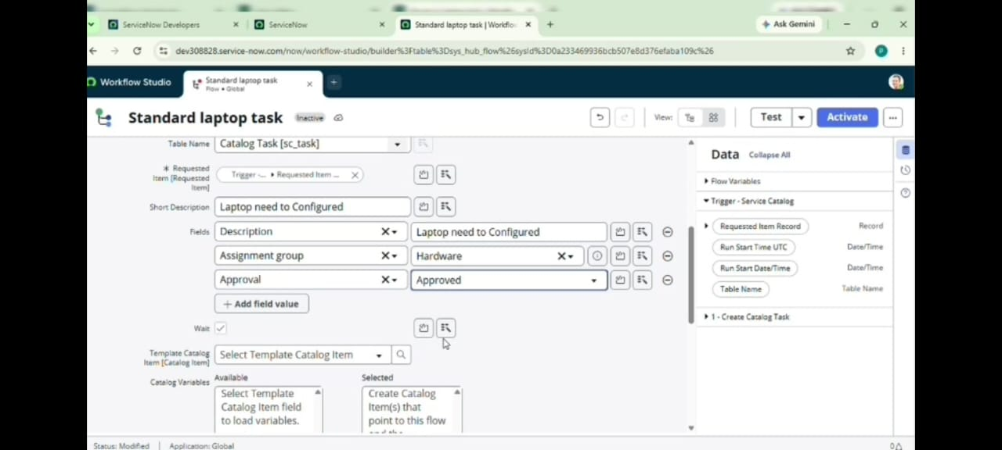

User Story:
The project is based on the following user story:
- As a member of the IT procurement team, I want a streamlined process for ordering standard laptops so that tasks are automatically generated and assigned to the hardware team for configuration.
- The user story focuses on automatically generating and assigning the required task after the request is approved.
- This helps ensure that laptops can be configured promptly and reduces the need for manual intervention.
Project Objective:
The main objective of the project is to implement an automated workflow using ServiceNow Flow Designer to facilitate the procurement and configuration of standard laptops.
The project aims to:
- Create a seamless experience for users requesting standard laptops.
- Ensure timely configuration of laptops.
- Reduce manual intervention.
- Reduce potential errors in the procurement process.
- Improve resource utilisation.
- Optimise task allocation.
- Improve overall efficiency and productivity in IT procurement operations.
Technologies and ServiceNow Components Used:
The project is implemented using the ServiceNow platform.
The main components used are:
1. ServiceNow
ServiceNow provides the platform in which the complete workflow is configured and executed.
2. Flow Designer
Flow Designer is used to create the automation required for the Standard Laptop procurement process.
3. Service Catalog
The Service Catalog provides the Standard Laptop item through which the user places the request.
4. Standard Laptop Service Catalog Item
The Standard Laptop item is used to initiate the laptop procurement request.
5. Service Catalog Trigger
The Service Catalog trigger starts the configured Flow for the relevant request.
6. Create Catalog Task
The Create Catalog Task action generates the task required for laptop configuration.
7. Requested Item
The Requested Item record is used during the creation and tracking of the Catalog Task.
8. Hardware Assignment Group
The generated Catalog Task is assigned to the Hardware group.
9. Approval Process
The request goes through the required approval before the Catalog Task is generated.

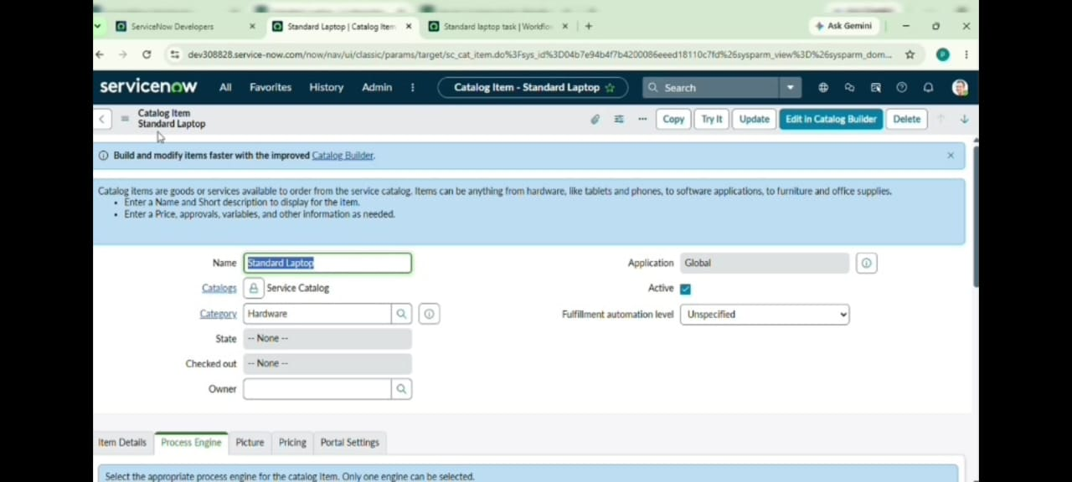

System Workflow:
The complete system workflow is:
Standard Laptop Request
↓
Request Approval
↓
Service Catalog Trigger
↓
Flow Designer
↓
Create Catalog Task
↓
Short Description – Laptop need to Configured
↓
Assignment Group – Hardware
↓
Hardware Team Configuration

This workflow reduces the need for manual task creation and assignment.
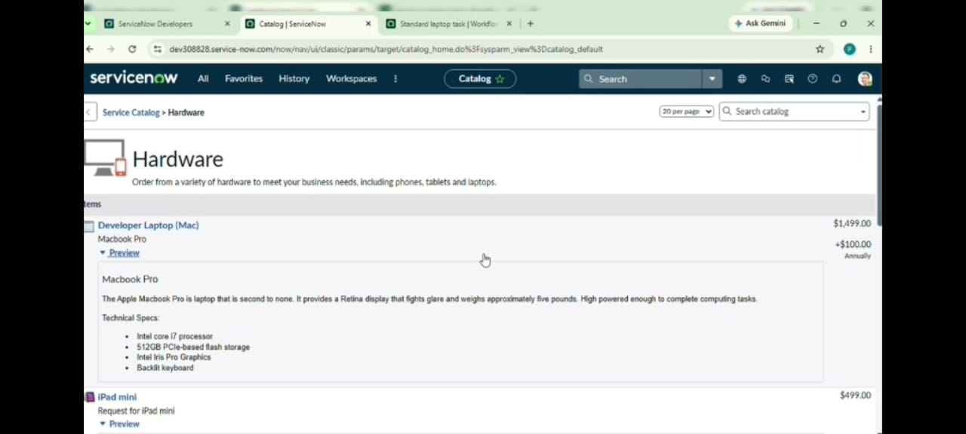

Flow Configuration:
The Flow created for the project is named:
Standard laptop task
The Flow configuration contains:
    - Application: Global
    - Run User: System user
    - Trigger: Service Catalog
    - Action: Create Catalog Task

The Requested Item Record is used as the Request item.
The Table is automatically populated as:
Catalog Task
The following values are configured in the Catalog Task:
Short Description: Laptop need to Configured
Description: Laptop need to Configured
Assignment Group: Hardware
Approval: Approved
The Flow is saved and activated after configuration.

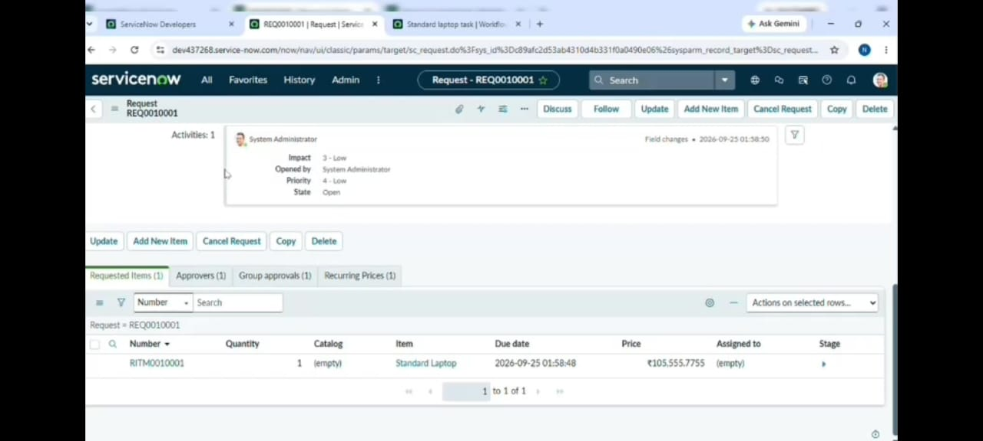
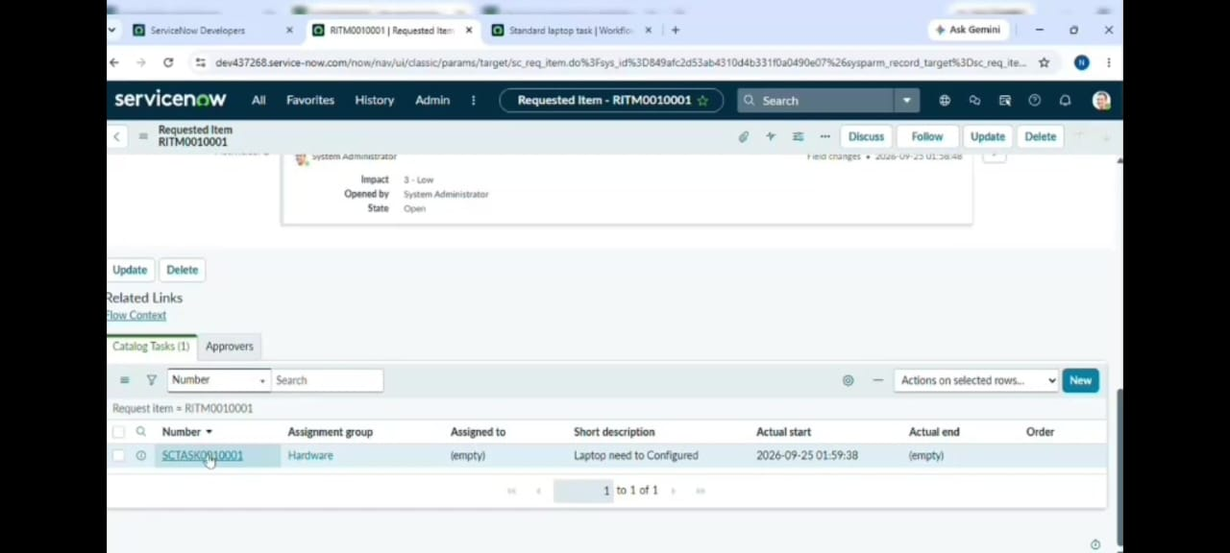

Flow Assignment to Standard Laptop:
- After creating and activating the Flow, it is assigned to the Standard Laptop Service Catalog item.
- The process is performed through
- All → Maintain Items → Standard Laptop → Process Engine
- The existing automation configuration is updated as required and the created Flow:
- Standard Laptop Task is added.
- The record is then saved.
- This connects the developed Flow with the Standard Laptop Service Catalog item.
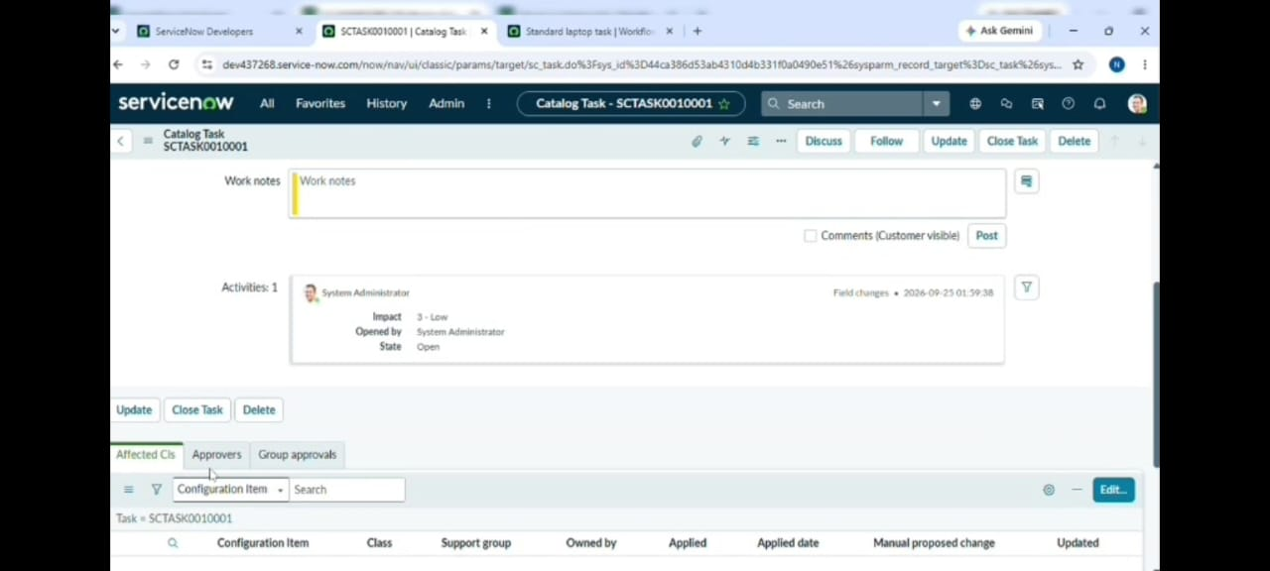

Standard Laptop Request Process:
- After the Flow is assigned, the Standard Laptop request is placed through the Service Catalog.
- The process is: All → Service Catalog → Hardware → Standard Laptop → Order Now
- After selecting Order Now, the Order Status is displayed.
- The Request Number is opened to access the request record.
Approval Process:
- The Request Number record contains the required request information.
- The Approvers section is accessed and the request is approved.
- The approval is an important stage of the automated process because the Catalog Task is created based on the configured approval condition.
- The approval flow is: Request Number → Approvers → Approve
Catalog Task Creation:
- After the request is approved, the Requested Item record is opened.
- The Catalog Tasks section is then checked.
- The Flow creates the Catalog Task based on the configured action.
- The generated task contains the required information.
The important task values are:
  - Short Description: Laptop need to Configured
  - Assignment Group: Hardware
  - Status: Updated task status
Final Output:
The final output of the project is an automatically generated Catalog Task for the Hardware team.
The expected final output contains:
Short Description: Laptops need to Be Configured
Assignment Group: Hardware
The generated task provides the Hardware team with the required task for laptop configuration.
This demonstrates the connection between the Service Catalog request, approval process, Flow Designer automation, and Catalog Task.
Testing Documentation:
The developed workflow was tested by following the Standard Laptop request process.
The main testing activities include:
- Place a Standard Laptop request.
- Open the Request Number.
- Check the Approvers section.
- Approve the request.
- Open the Requested Item.
- Check the Catalog Tasks section.
- Open the generated Catalog Task.
- Verify the Short Description.
- Verify the Assignment Group.
- Verify the task status.
The expected result is that the approved Standard Laptop request generates a Catalog Task containing the configured information and assigns it to the Hardware group.
Project Benefits:
The implemented automation provides several benefits:
- Reduced Manual Intervention
- The Catalog Task is created automatically instead of requiring manual task creation.
- Improved Task Allocation
- The task is automatically assigned to the Hardware group.
- Reduced Processing Delays
- Automation helps initiate the configuration task after the required approval.
- Improved User Experience
- The streamlined process can reduce waiting time for users requesting standard laptops.
- Better Resource Utilisation
- Tasks are directed to the appropriate team, supporting better utilisation of IT resources.
- Improved Process Efficiency
- The automated workflow reduces unnecessary manual activities in the procurement process.
- Consistent Task Creation
The configured Flow provides a standard process for generating the required Catalog Task.
Before and After Process:
Existing Process:
Standard Laptop Request
↓
Manual Follow-up
↓
Task Creation
↓
Task Assignment
↓
Laptop Configuration

The manual activities may result in delays and additional effort.

Automated Process:
Standard Laptop Request
↓
Approval
↓
Automated Flow
↓
Catalog Task Created
↓
Hardware Assignment
↓
Laptop Configuration

The automated process provides a more structured workflow.
Complete Project Workflow:
The complete project can be represented as:
User Requests Standard Laptop
↓
Service Catalog
↓
Order Now
↓
Request Number Generated
↓
Approver Reviews Request
↓
Request Approved
↓
Service Catalog Trigger
↓
Flow Designer Executes
↓
Create Catalog Task
↓
Short Description Added
↓
Assignment Group – Hardware
↓
Hardware Team Receives Task
↓
Laptop Configuration
↓
Task Status Updated

This represents the complete automated workflow implemented in the project.
Project Deliverables:
The major project deliverables include:
- Configured ServiceNow Flow.
- Standard Laptop Service Catalog configuration.
- Flow assignment to the Standard Laptop item.
- Automated Catalog Task creation.
- Hardware assignment configuration.
- Approval workflow.
- Testing results.
- Project documentation.
- ServiceNow screenshots as implementation evidence.
- Project demonstration material.
Project Documentation Structure:
The complete project documentation is divided into the following phases:

Phase | Title | Main Content
Phase 1 | Brainstorming & Ideation | Problem, User Story, Idea and Objectives
Phase 2 | Requirement Analysis | Functional and platform requirements
Phase 3 | Project Design | Workflow and system design
Phase 4 | Project Planning | Milestones and implementation plan
Phase 5 | Project Development | Actual ServiceNow implementation
Phase 6 | Project Testing | Test cases and results
Phase 7 | Project Documentation | Complete project implementation documentation
Phase 8 | Project Demonstration | Project demonstration and explanation

This table can be included because Phase 7 is the documentation phase and it summarizes the complete project structure.

Project Conclusion:

- The project “Streamlining IT Procurement: Automating Standard Laptop Orders with Flow Designer” implements an automated workflow for processing Standard Laptop requests.

- The project uses ServiceNow Flow Designer to create a Catalog Task after the required approval. The generated task contains the required Short Description and is assigned to the Hardware group.

- The workflow connects the Standard Laptop Service Catalog, approval process, Flow Designer, Requested Item, and Catalog Task into a structured automated process.

- The implementation helps reduce manual intervention, supports timely task creation, improves task allocation, and provides a streamlined approach to standard laptop procurement and configuration.

